CAMPUS AMBASSADOR
APPLICATION

Are you committed to ending sexual assault and dating abuse on your campus? Join the movement and become a Campus Ambassador for 2018!
In partnership with Hillel of Broward and Palm Beach, JWI is working to end sexual assault and dating abuse at Florida Atlantic University! As a Campus Ambassador, you’ll take a leadership role to continue the conversation about sexual assault & dating abuse on your campus. This position gives you the opportunity to gain valuable experience, and build your resume. JWI provides the tools, training and resources to build awareness and create the change!

About JWI: Jewish Women International (JWI ) is a leading progressive organization committed to ending gender-based violence, in secular and faith spaces, nationally and at the community level. Change the Culture has reached over 45 college campuses nationwide.

As a Campus Ambassador, you will:
Coordinate a Brave Miss World Film Screening and Discussion
Miss Israel – Linor Abargil – was raped at the age of 18. She had to represent her country in the Miss World competition only six weeks later. When to her shock she was crowned the winner, she vowed to do something about rape. The film explores the trauma of sexual assault through one young woman’s activist journey.

Ambassadors are responsible for:
- Securing a date, time, and space
- Securing event co-sponsorships from other campus student organizations
- Advertising the event and doing campus outreach
- Identifying facilitators for the post screening discussion on supporting survivors
Implement a Public Awareness Campaign
Get the conversation going on dating abuse and sexual assault using social media and posters. JWI will provide materials, and you make it happen!
Ambassadors are responsible for:
- Helping develop messages that address your campus culture
- Hanging flyers on campus and posting on social media
- Encouraging community members to post about the campaign on social media

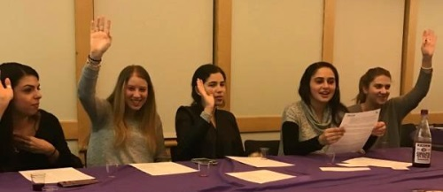
Organize a Shabbat Program on Relationships
Relationships matter, but creating the space and time to reflect on them can be difficult. From friends to dating partners, it can be hard to build trust, find support, and communicate effectively. This program includes activities to build positive connections & strengthen relationships.

Ambassadors are responsible for:
- Providing feedback and ideas to create a campus specific Shabbat program
- Securing a date, time, and space
- Advertising the event and doing campus outreach
- Identifying peers to be table leaders

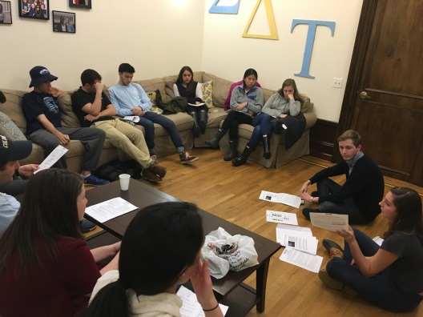
Organize a Prevention Workshop
Pick a sexual assault and dating abuse prevention workshop from JWI’s menu of programmatic options. Workshop topics include consent, victim blaming, communicating boundaries, hook up culture, gender norms, bystander intervention, and supporting survivors.

Ambassadors are responsible for:
- Selecting a prevention workshop
- Securing a date, time, and space
- Advertising the event and doing campus outreach
- Identifying peer leaders to facilitate the program

Qualifications:
- Is a current student at FAU who will be on campus (i.e., not abroad) for Spring & Fall of 2018
- Is an active member of the Hillel of Broward and Palm Beach community
- Demonstrates strong communication, interpersonal, planning, and writing skills
- Possesses student leadership experience (on or off campus and in the community)

Applications considered on a rolling basis. Ambassadors receive a $250 stipend per semester. E-mail your resume and responses to the questions below to JWI’s Manager of Prevention Programs, Ariella Neckritz, at aneckritz@jwi.org with the subject line “Campus Ambassador Application.”
Name:
Expected Graduation Year:
Major:
Minor (if any):
E-mail:
Phone Number:
1. Why do you want to be a JWI Campus Ambassador? (250 words maximum)
2. What would make you a great Campus Ambassador? What qualities and/or skills do you have that will help you succeed in this role? (250 words maximum)
3. Please list any academic, extra-curricular, internship or other experience that you think would be relevant. What are you most proud of, and why? (250 word maximum)

